FAST-NUCES KARACHI CAMPUS
(SPRING-2026)


COURSE:
(CS-3009) SOFTWARE ENGINEERING

[THEORY ASSIGNMENT-I]

SECTION:
BS-CS-6A

INSTRUCTOR:
DR. SOBIA IFTIKHAR

NAME:
K230907 ZUBAIR AHMED

T1: UNDERSTANDING THE DESIGN PROBLEM
CORE PROBLEM IN DESIGN TERMS:
The existing AlphaSoft system relies on a fixed interface (PaymentService with pay(double amount)). The newly acquired third-party payment services have different method names, parameter lists, and return types. Since neither the client code nor the third-party classes can be modified, we need a way to make them work together without changing either side. This is a classic interface mismatch problem.

WHY NAIVE SOLUTIONS FAIL?
Modifying the client to directly call third-party methods would break the existing codebase and violate the "no changes" rule written in the assignment.

Modifying the third-party classes is forbidden, they are "battle-tested" and cannot be rewritten.

Using conditional logic in the client (e.g., if (service instanceof LegacyPayService)) would couple the client to concrete classes and make it hard to add new providers, it violates the Open/Closed Principle.

Copying the third-party code is not allowed; we must reuse them as they are.

KEY INTERFACES AND CLASSES:
TARGET INTERFACE: PaymentService, the interface AlphaSoft expects (contains a pay method).

CLIENT: PaymentClient uses PaymentService and must remain unchanged.

ADAPTEES: Third-party services like LegacyPayService (with makePayment), CentPayService (with payInCents), etc. They have incompatible interfaces.

ADAPTER: A new class that implements PaymentService and internally delegates to the adaptee, translating the method call appropriately.

T2: DEFINING THE CORE CONTRACTS AND EXISTING COMPONENTS
WHAT ALPHASOFT EXPECTS:
AlphaSoft’s system defines a contract through the PaymentService interface. Any payment provider must implement this interface, providing a method boolean pay(double amount). The client (PaymentClient) is written against this interface and knows nothing else.

EXISTING COMPONENTS:
PaymentService (interface): the core contract.
PaymentClient: the unmodifiable client code.
LegacyPayService: An example third-party class with method makePayment(double valueInDollars).

These components are initially incompatible because LegacyPayService does not implement PaymentService. Attempting to use it directly causes a compilation error.

DESIGN PATTERN USED: ADAPTER PATTERN
The solution uses the ADAPTER pattern.

It allows a class with an incompatible interface to be used as if it implemented the target interface, without changing either the client or the adaptee.

We create a new class (e.g., LegacyPayIntegration) that implements PaymentService. Inside its pay method, it calls the appropriate method on the third-party service (e.g., legacy.makePayment(amount)).

This class acts as a translator.

BASE COMPILATION
cd C:\Users\zubai\Downloads\Java\CS3009-SE-A1\base

javac -d . core\PaymentService.java client\PaymentClient.java client\Main.java external\LegacyPayService.java integration\LegacyPayIntegration.java

java com.alphasoft.base.client.Main
OUTPUT
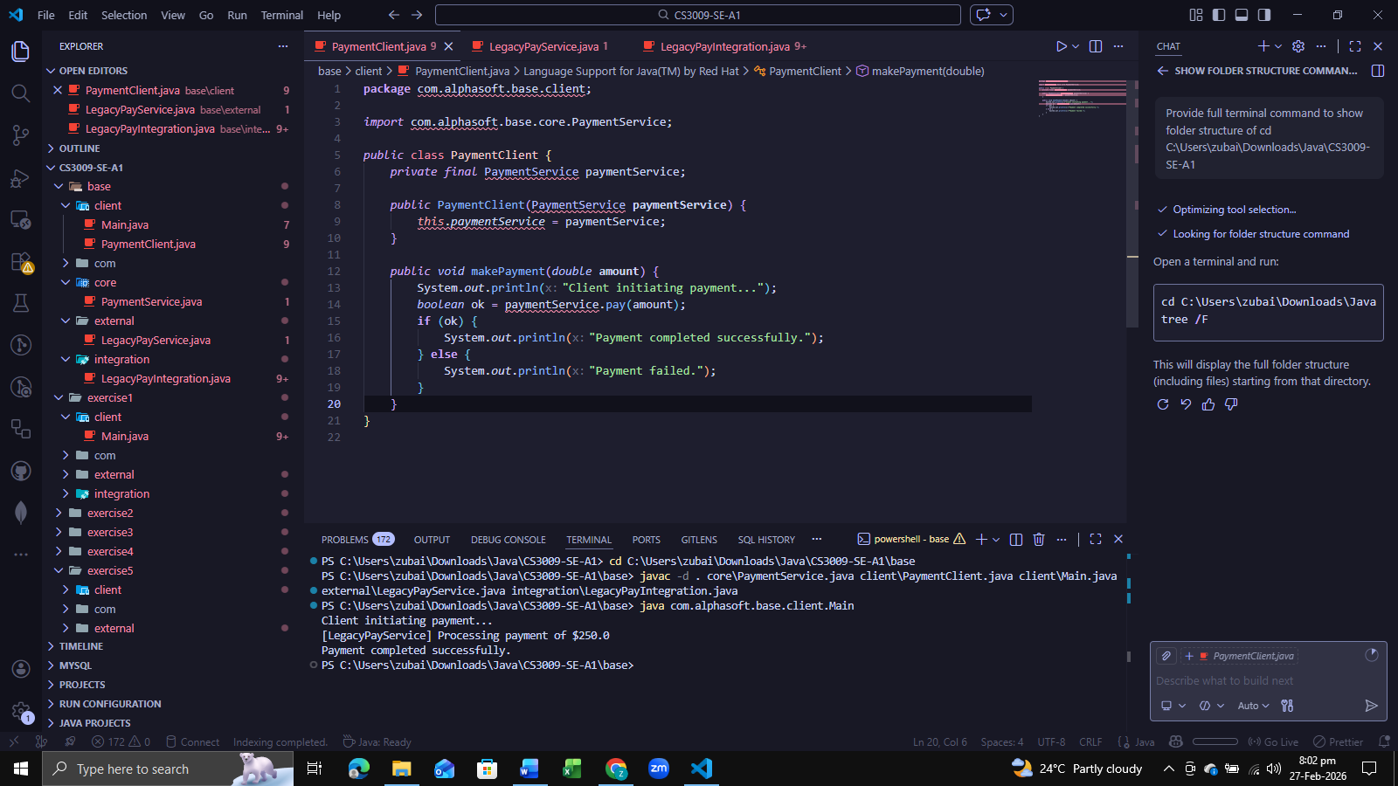

EXCERCISE 1 COMPILATION
cd C:\Users\zubai\Downloads\Java\CS3009-SE-A1\exercise1

javac -d . ..\base\core\PaymentService.java ..\base\client\PaymentClient.java external\CentPayService.java integration\CentPayIntegration.java client\Main.java

java com.alphasoft.exercise1.client.Main
OUTPUT
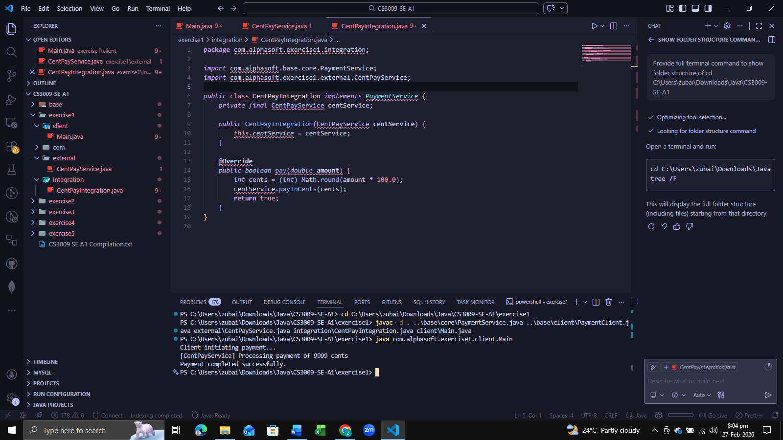

EXCERCISE 2 COMPILATION
cd C:\Users\zubai\Downloads\Java\CS3009-SE-A1\exercise2

javac -d . ..\base\core\PaymentService.java ..\base\client\PaymentClient.java external\GlobalPayService.java integration\GlobalPayIntegration.java client\Main.java

java com.alphasoft.exercise2.client.Main
OUTPUT
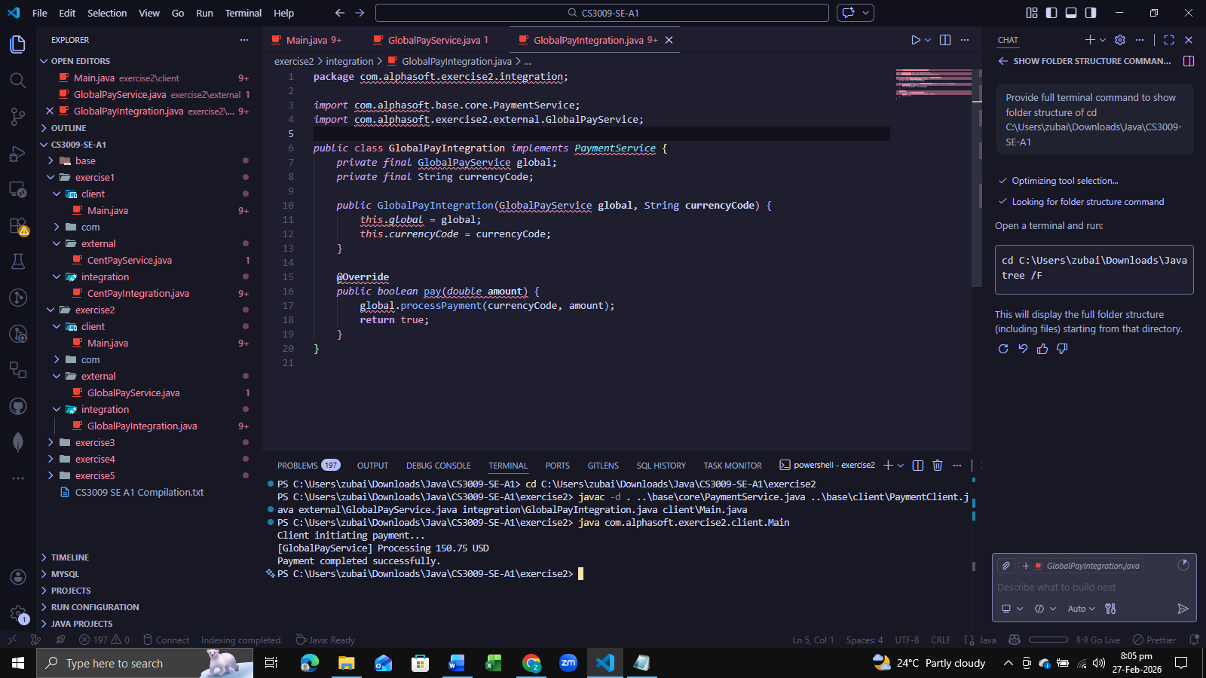

EXCERCISE 3 COMPILATION
cd C:\Users\zubai\Downloads\Java\CS3009-SE-A1\exercise3

javac -d . ..\base\core\PaymentService.java ..\base\client\PaymentClient.java external\ConfirmPayService.java integration\ConfirmPayIntegration.java client\Main.java

java com.alphasoft.exercise3.client.Main
OUTPUT
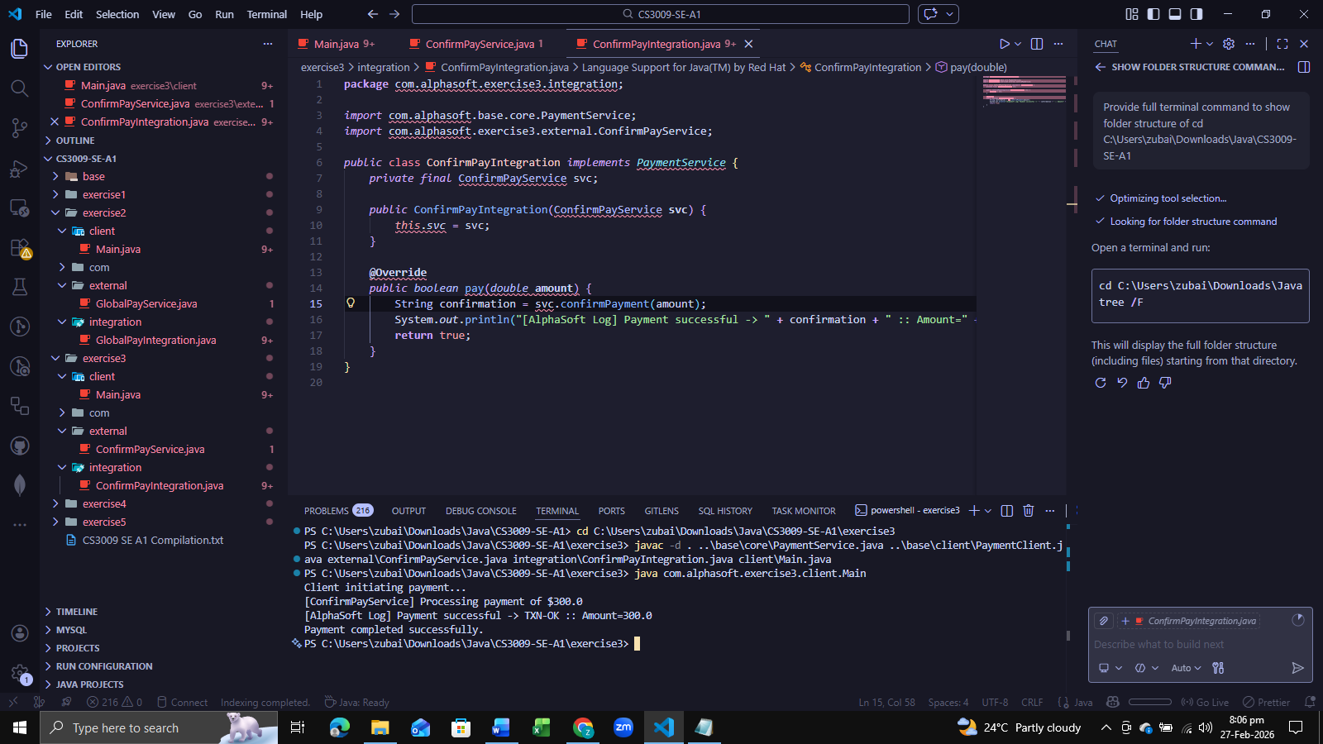

EXCERCISE 4 COMPILATION
cd C:\Users\zubai\Downloads\Java\CS3009-SE-A1\exercise4

javac -d . ..\base\core\PaymentService.java ..\base\client\PaymentClient.java external\LegacyPayService.java external\GlobalPayService.java integration\LegacyPayIntegration.java integration\GlobalPayIntegration.java integration\ProviderRegistry.java integration\SwitchablePaymentService.java client\Main.java

java com.alphasoft.exercise4.client.Main
OUTPUT
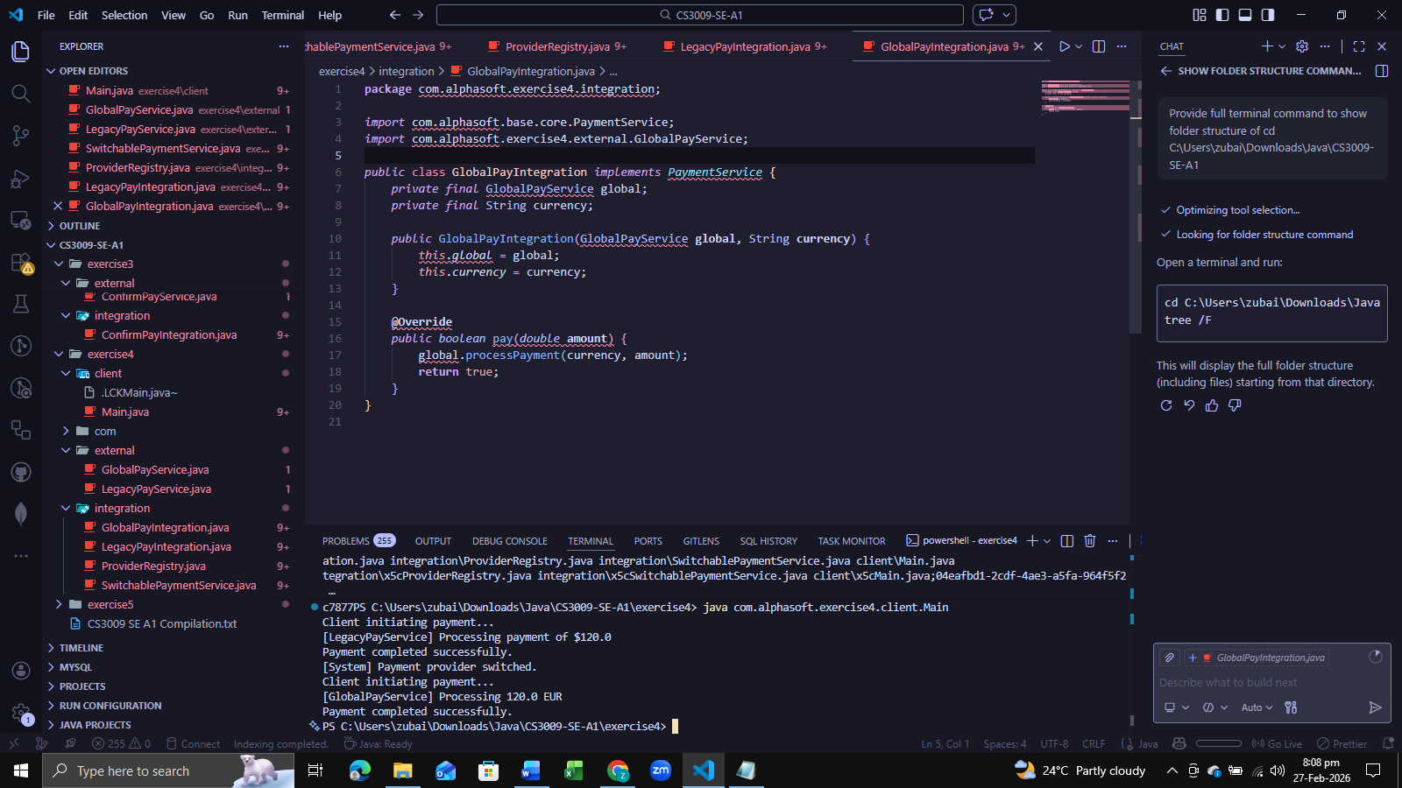

EXCERCISE 5 COMPILATION
cd C:\Users\zubai\Downloads\Java\CS3009-SE-A1\exercise5

javac -d . ..\base\core\PaymentService.java ..\base\client\PaymentClient.java external\MockPayService.java integration\MockPayIntegration.java client\Main.java

java com.alphasoft.exercise5.client.Main
OUTPUT
